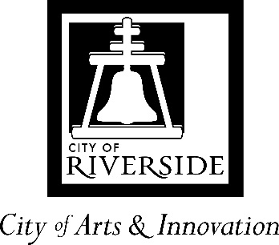
City Council Memorandum

TO: HONORABLE MAYOR AND CITY COUNCIL DATE: SEPTEMBER 17, 2024

FROM: PARKS, RECREATION AND COMMUNITY WARDS: ALL
SERVICE DEPARTMENT

SUBJECT: SECOND AMENDMENT TO PROFESSIONAL CONSULTANT SERVICES AGREEMENT WITH PLANTATION PRODUCTIONS, INC., OF RIVERSIDE, CALIFORNIA, TO PROVIDE LOGISTICAL AND TECHNICAL SUPPORT FOR THE BOX AT THE FOX ENTERTAINMENT PLAZA, TO EXTEND THE AGREEMENT TO JUNE 30, 2025, AND INCREASE THE TOTAL AMOUNT NOT TO EXCEED $367,500

ISSUE:

Approve the second Amendment to Professional Consultant Services Agreement to provide logistical and technical support with Plantation Productions, Inc., of Riverside, California, to provide logistical and technical support for The Box at the Fox Entertainment Plaza, to extend the agreement term to June 30, 2025, and increase the existing not to exceed amount to $367,500.

RECOMMENDATIONS:

That the City Council:

- Approve the Second Amendment to Professional Consultant Services Agreement to provide logistical and technical support for The Box with Plantation Productions, Inc., of Riverside, California, to extend the term to June 30, 2025, and increase the existing not to exceed amount to $367,500; and

- Authorize the City Manager, or his designee, to execute the Second Amendment to Professional Consultant Services Agreement with Plantation Productions, Inc., of Riverside, California, including making minor and non-substantive changes.

BACKGROUND:

Opening in May 2013, The Box at the Fox Entertainment Plaza (The Box) is a community theater that doubles as a state-of-the-art flexible facility that seats approximately 200 patrons. The Box is a unique space for small, intimate experiences for dance, musical, theatrical, multimedia, and educational productions. It is ideal for rehearsals, classes, receptions, and meetings for nonprofit based or commercial organizations.

The Box is mostly used by local nonprofit performing arts organizations. Shows have ranged from one-day move-in/move-outs to multi-week performances. Most often performances take place on Friday and Saturday evenings with matinee shows on Sunday. Events vary from theatrical, dance performances and recitals, to comedy shows. The facility is also used for meetings, small conferences, and classes. During the summer season, the space is used by organizations holding summer camps for children.

 | Approximate number of users | Number of Rental Days | Approximate Visitors
2023 | 22 | 140 | 3,240
2024 (to date) | 17 | 101 | 1,950

Plantation Productions Inc. provides technical, house managers, and administration of the rentals. Theater users pay a facility rental fee and staff fee that offsets the cost of maintenance and Plantation Production services fee. The fees paid vary depending on user status as nonprofit or commercial. (Attachment 1).

Ticket sales are managed by the organizers of events and revenue goes directly to the organizer. The new website for the theater was launched mid-summer and staff is working with organizers to begin to build a cohesive marketing plan for events held at The Box. The website serves as a centralized platform providing general information for the facility and will be hosting event information for upcoming performances.

The Box serves as a community theater with a focus on nonprofit local serving organizations. There are maintenance costs associated with maintaining the facility open and available to these community groups.

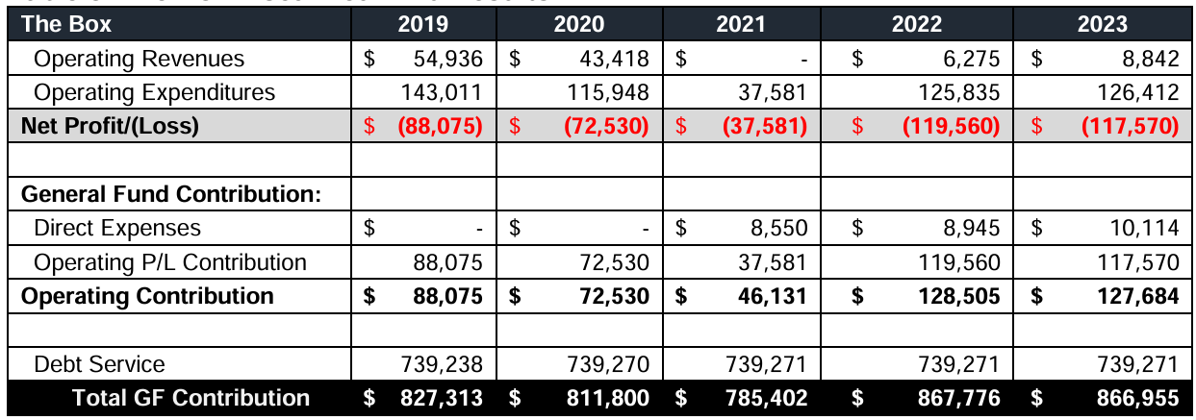
*Direct expenses include utilities for entire building including downstairs -Gamelab and upstairs theater.

On May 12, 2021, Request for Proposals (RFP) 2104 was posted on PlanetBids to solicit proposals from qualified consultants to provide operational and management services for The Box. Eleven prospective bidders registered for the RFP. The RFP closed on May 27, 2021, and only one proposal was received, from Plantation Productions, Inc. of Riverside, California. A selection committee of three City staff members reviewed and scored the proposals based on qualifications, experience, references, and approach and methodology. After careful review and consideration, the evaluation committee determined that the proposal from Plantation Productions, Inc. was the best choice for the city. Plantation Productions, Inc. entered into an agreement through June 30, 2023. The Agreement includes two options to extend for two (2) additional one-year terms. On August 15, 2023, the City Council approved a First Amendment to allow Plantation Productions, Inc. to continue logistical and technical support for The Box through June 30, 2024.

DISCUSSION:

Since the opening of The Box in 2013, community theater groups, schools, music groups, dance troops and film festivals have rented the space. On average, each rental may include several rental days for auditions, rehearsals, load-in/out, and performance days.

Plantation Productions, Inc. has over 15 years of experience providing professional production services. Plantation Productions, Inc. is a Riverside-based business, and many of its employees are Riverside residents. Plantation Productions, Inc. has provided these services at The Box for over five years. Their experience allows them to provide the services needed to support community organizations, event organizers, and visitors to The Box. The team provides visitors and users with excellent customer service and is able to respond to the immediate needs of users.

The Agreement includes options to extend for two (2) additional one-year terms. The First Amendment allowed Plantation Productions, Inc. to continue logistical and technical support for The Box through June 30, 2024. During this time, Plantation Productions provided technical services, maintained communication with staff on issues at the facility, and ensured users and visitors had pleasant experiences at the theater resulting users returning on an annual basis. The Second Amendment will allow for an additional year of service by Plantation Productions, Inc. at The Box theater through June 30, 2025.

STRATEGIC PLAN ALIGNMENT:

This item contributes to Strategic Priority No. 1 and Goal No. 1.2 – Enhance equitable access to arts, culture and recreational service offerings and facilities.

The item aligns with each of the five Cross-Cutting Threads as follows:

- Community Trust – The contracted professional services align with the needs of community and professional performing arts groups that have shared feedback and input from the Box Committee.

- Equity – The Box serves as a facility enhancing equitable access to arts and culture and is a valued place for the community to gather and experience arts and culture.

- Fiscal Responsibility- The contracted professional services are scheduled with and included as part of the rental fee for organizations using The Box. The costs are passed through from the event fee to the contracted provider. The contractor was selected through a competitive procurement process.

- Innovation – The Box is used by community groups of all ages and diverse backgrounds. Theater through expression, storytelling, and creativity has the potential to ignite social development, strengthen the sense of community, and develop emerging artists.

- Sustainability & Resiliency – Maintaining services at The Box ensures our city’s local performing arts groups and audience have a community space to contribute to the creative economy, to the development of skills and creative workforce, and further community pride.

FISCAL IMPACT:

The total fiscal impact of the action is $367,500. The funds are available in The Box Account Number 5241020-421000.

Prepared by: Margery Haupt, Parks, Recreation and Community Service Deputy Director
Approved by: Pamela Galera, Parks, Recreation and Community Service Director
Certified as to
availability of funds: Kristie Thomas, Finance Director/Assistant Chief Financial Officer
Approved by: Kris Martinez, Assistant City Manager
Approved as to form: Phaedra A. Norton, City Attorney

Attachment:

- The Box Rental Fees
- Second Amendment to Professional Consultant Services Agreement with Plantation Productions, Inc.

