

City Council Memorandum

TO: HONORABLE MAYOR AND CITY COUNCIL DATE: FEBRUARY 4, 2025

FROM: COMMUNITY & ECONOMIC DEVELOPMENT WARD: 3
DEPARTMENT

SUBJECT: LETTER OF COMMITMENT WITH THE DEPARTMENT OF GENERAL SERVICES FOR THE ACQUISITION OF PERMANENT AND TEMPORARY CONSTRUCTION EASEMENTS LOCATED AT 6280 BROCKTON AVENUE, BEARING ASSESSOR’S PARCEL NUMBER 225-041-007, NOT TO EXCEED THE AMOUNT OF $75,000

ISSUE:

Approve the Letter of Commitment with the Department of General Services for the acquisition of permanent and temporary construction easements located at 6280 Brockton Avenue, bearing Assessor’s Parcel Number 225-041-007, not to exceed the amount of $75,000.

RECOMMENDATIONS:

That the City Council:

- Approve the Letter of Commitment (Attachment 1) with the State Department of General Services (DGS) for the acquisition of a permanent and temporary construction easement located at 6280 Brockton Avenue, bearing Assessor’s Parcel Number 225-041-007, not to exceed the amount of $75,000; and

- Authorize the City Manager, or his designee, to execute the Letter of Commitment, including making minor and non-substantive changes, and to sign all documents and instruments necessary to complete the transaction.

BACKGROUND:

On April 10, 2018, the City Council approved the concept design and alternative concept design for the Palm Avenue/Union Pacific Railroad crossing and directed the Public Works Department to complete the project design and file a Notice of Intent to create a new quiet zone at the Palm and Brockton Avenues Rail crossings. This quiet zone will benefit the surrounding community consisting of residences, businesses and a local DMV office with a reduction in train horn use.

DISCUSSION:

The subject site (Property), which is required for the Palm Avenue & Brockton Avenue Rail Crossing Quiet Zone Project (Project), is located at 6280 Brockton Avenue on the northeast corner of Brockton Avenue adjacent to the Union Pacific Railroad tracks. The Property, as shown in the street view below, is zoned Office (O) with a General Plan designation of Mixed Use-Neighborhood (MU-Neighborhood) in the Magnolia Center area.
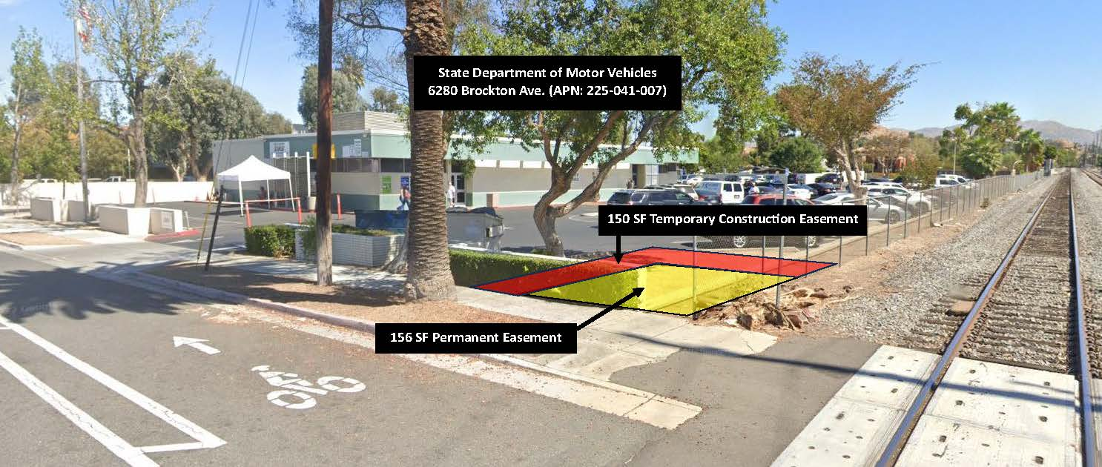
Staff, on behalf of the City of Riverside’s Public Works Department, negotiated the acquisition of a 156 square foot permanent easement and a 150 square foot temporary construction easement (TCE), for a duration of twelve (12) months, including construction of a block wall and landscaping.

Staff obtained an independent third-party appraisal which valued the TCE, permanent easement and improvements at a lump sum of $7,200. Staff have determined that the $7,200 represents the fair market value of the interest to be acquired.

The State Department of Motor Vehicles (DMV) relies on DGS to review and process all acquisitions. However, because of the difficulties in anticipating and capturing all potential costs that may be associated with a project, including administrative costs and any rights to be conveyed, DGS requires a commitment letter from the acquiring party.

DGS provided the following guidelines for the Letter of Commitment:

The City of Riverside (City) will be responsible for DGS’ project administrative fees and reimbursements costs which are required for their review:

- Payment of the DGS' administrative costs including but not limited to project review and analysis; document preparation and coordination; confirmation of market value; engineering review; etc. The current billing rate for DGS Transaction Review Unit's services is $217 per hour (subject to change and other rates may apply if support from other offices within the DGS is necessary); and
- Payment of the costs of the permanent and temporary property rights conveyed to the City.

The City will be responsible for providing the following items and services at no cost to the State:

- Appraisal of transactional impacts to the Facility. NOTE: A meeting for appraisal valuation purposes is recommended prior to the County proceeding further with an appraisal.
- Project written legal descriptions/maps/sketches.
- Preliminary Reports, vesting documents, reference documents, and hyperlinked title exceptions for all applicable areas at the Facility affected by the City’s project.
- Documents regarding CEQA compliance including the filing of the Notice of Determination and expiration of the Statute of Limitations period, for the City’s project and to be completed prior to the State’s execution of any agreements.
- All CEQA mitigation requirements for the City’s project.
- Timely recordation/distribution of real property easement, conveyance, and/or transfer documents.
- Consultation/coordination.
- Scope of project which includes project location and drawings.

Prior to continuing work on the project, DGS will require the following:
- A Letter of Commitment from the City for DGS’ estimated administrative costs stated below for the permanent and temporary rights conveyed. Since the final project resolution and review is pending, the costs for the approved permanent and temporary rights are currently not available. These costs will be due at the time of final document execution or should DGS elect, in increments prior to final document execution or upon transaction cancellation. There is no stated or implied guarantee the State will move forward with the transaction.

DGS’ initial review provided for the following estimates:
- Costs for the rights to be conveyed have not yet been determined/approved.
- DGS’ estimated administrative costs are currently ………………………………. $40,000
- DGS’ estimated appraisal review costs per appraisal provided are currently … $11,000
$51,000

Discovery of new information during project processing/review, changes in project scope, levels of complexity, and/or the timely presentation of related documents, among others, could impact the cost estimates and delivery schedules.

The Director of the Public Works Department concurs with the recommendations in this report.

STRATEGIC PLAN ALIGNMENT:

This item contributes to the Envision Riverside 2025 Strategic Plan, Priority No. 5 – High Performing Government. Specifically, Goal 5.4 – Achieving and maintaining financial health by addressing gaps between revenues and expenditures and aligning with the strategic priorities to yield the greatest impact.

The item aligns with each of the five Cross-Cutting Threads as follows:

- Community Trust – The City is transparent and makes decisions based on sound policy, inclusive engagement, involvement of City Boards and Commissions, and reliable information. Approving the Letter of Commitment shows that the City serves the public interest that benefits the City’s diverse populations and results in the greater public good.

- Equity – The City is supportive of the City’s racial, ethnic, religious, sexual orientation, identity, geographic, and other attributes of diversity. Approving the Letter of Commitment shows that the City is committed to advancing the fairness of treatment, recognition of rights, and equitable distribution of services ensuring that every member of the community has equal access to share in the benefits of community progress.

- Fiscal Responsibility – The City is a prudent steward of public funds. Approving the Letter of Commitment ensures responsible management of the City’s financial resources while providing quality public services to all.

- Innovation – The City is inventive and timeline in meeting the community’s changing needs. Approving the Letter of Commitment shows that the City prepares for the future through collaborative partnerships and adaptive processes.

- Sustainability & Resiliency – The City is committed to meeting the needs of the present without compromising the needs of the future. Approving the Letter of Commitment ensures the City’s capacity to persevere, adapt and grow during good and difficult times alike.

FISCAL IMPACT:

The total fiscal impact of this action is not to exceed $75,000 for the proposed acquisition of the easements in the amount of $7,200 and DGS’ estimated cost of processing the request in the amount of $51,000. An additional $5,000 is estimated for the cost of escrow, title, and related fees for an approximate total of $63,200. Sufficient funds are budgeted and available in the Gas Tax Fund, UP Quiet Zone – Brockton & Palm Project account number 9872127-440223 to execute the Letter of Commitment with DGS.

Prepared by: Ron Duran, Real Property Agent
Approved by: Jennifer A. Lilley, Community & Economic Development Director
Certified as to
availability of funds: Kristie Thomas, Finance Director/Assistant Chief Financial Officer
Approved by: Mike Futrell, City Manager
Approved as to form: Jack Liu, Interim City Attorney

Attachments:
- Letter of Commitment – Department of General Services
- Presentation

